**TempRecoder: Global Temperature Change Visualization**

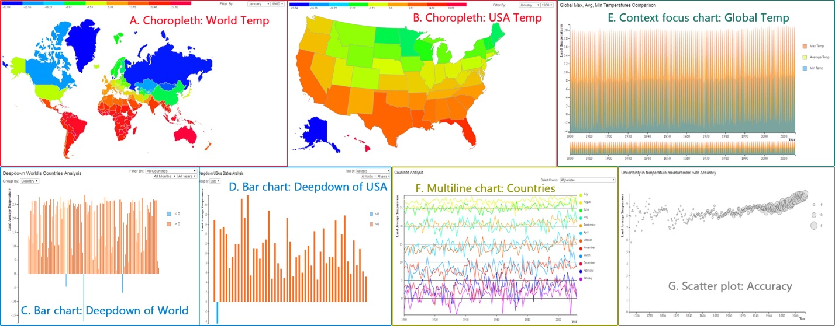

Fig 1: TempRecorder, a historical temperature visualization tool. A) A choropleth of the world map indicating the average land temperature across globe from 1900 to 2013, B) A choropleth of the USA map indicating the average land temperature across USA from 1900 to 2013, C) A bar chart indicating the deep down analysis of land temperature across countries, D) A bar chart indicating the deep down analysis of land temperature across states of USA, E) A context focus chart indicating the global maximum, average, minimum land temperatures from 1900 to 2013, F) A multiline chart with complete analysis for every country from 1900 to 2013, G) A scatter plot for uncertainty in temperature measurement with accuracy from 1750 to 2015

**Abstract** - Climate change also called global warming refers to the rise in average surface temperatures on Earth. Global warming is projected to have a number of effects on the oceans. Ongoing effects include rising sea levels due to thermal expansion and melting of glaciers and ice sheets, and warming of the ocean surface, leading to increased temperature stratification. Since the industrial revolution, scientists have observed a continued and accelerating rise in the levels of greenhouse gases in the atmosphere. Over the last century, scientists have measured a 0.5-degree rise in average global temperatures that is due, at least in part, to increased levels of greenhouse gases. How will land plants respond to these changes in temperature and carbon dioxide levels? Will they delay or accelerate the global warming trend? Can we analyze historical data to predict the future land temperature changes?

|  |  |  |
| --- | --- | --- |
| **INTRODUCTION**  As atmospheric concentrations of carbon dioxide continue to increase, the Earth's climate is expected to change significantly over the next several decades. In response, scientists expect to see gradual shifts in the regional distribution of plant species.  Moreover, there is speculation that rising temperatures and heightened carbon dioxide |  | levels will accelerate the photosynthesis and growth rates of plants. Less well known is the critical role that vegetation will play in the carbon cycle and global warming. Scientists have carefully scrutinized and compared the amount of carbon dioxide released by fossil fuel burning to the rate of carbon dioxide buildup in the atmosphere and the amount absorbed by the oceans and land surfaces. |

They have concluded that over the past 15 years, approximately one-quarter of industrial carbon dioxide emissions have been absorbed and stored by the vast vegetated areas of the Northern Hemisphere, primarily the boreal and temperate forests of North America and Eurasia.

In addition to the carbon cycle, vegetation plays a direct role in other aspects of the Earth's climate. Green leaves are relatively dark, allowing for vegetated land to absorb more of the Sun's energy than light-colored deserts or snow-covered surfaces, which reflect most incoming solar radiation. Vegetation takes up water from the soil and releases it back to the atmosphere as water vapor, process called "evapotranspiration" New studies suggest that higher levels of carbon dioxide in the atmosphere, coupled with higher temperatures, could alter evapotranspiration rates, which would impact both the hydrological cycle as well as land plant biomes.

**1 RELATED WORK**

**1.1 LITERATURE SURVEY**

For this project, our group focused on existing research paper on changing in land temperatures.

Research by Scott R. Loarie et al. (2009) [1] studies ecosystems’ response to recent changes in climate. As temperature rise, ecosystems which cannot change, such as mountains, are considered to be more threatened. The article presents a new index of velocity of temperature change (km/yr) derived from spatial gradients and multi-model ensemble forecasts of rates of temperature increase. The results indicate management strategies for minimizing bio-diversity loss from climatic change. From the results, it is imperative that we need to gain more insights about the temperature change globally.

James Hansen et al. (2006) [2] conducted a study on global surface temperature from which they determined that global surface temperature has increased 0.2°C per decade in the past 30 years, similar to the warming rate predicted in the 1980s in initial global climate model simulations with transient greenhouse gas changes. Warming is larger in the Western Equatorial Pacific than in the Eastern Equatorial Pacific over the past century. The pattern of global warming has assumed expected characteristics, with high latitude amplification and larger warming over land than over ocean. This pattern results mainly from the ice–snow the response times of ocean and land. After observing the lot of changes in temperature based on geography, across past decades, it is interesting to visualize the changes in temperature and, how it affects the atmosphere? What is the rate of change of temperature across different decades?

Study conducted by Robert Rohde et al. (2013) [3] reveals that global land mean temperature (comparing the average of the period 2001-2010 with that of 1951-1960) has increased by 0.90 ± 0.05°C (95% confidence). This change is consistent with the global land-surface warming results previously reported, but with reduced uncertainty. There are large differences between the surface temperatures of the hemispheres, and among the seven continents over the period. This triggers a curiosity to find the reasons behind it.

**2 SYSTEM DESIGN**

The design of TempRecoder is divided into three sections. First we had to obtain and cleanse the relevant data. Next we had to build tasks and use cases for the system. Finally, we had to implement visualizations for multiple attributes and connect them to the predictive model.

**2.1 Obtaining and Cleansing the Data**

For our project data, we downloaded historical data about land temperature at <http://berkeleyearth.org/>. This data set combines 1.6 billion temperature reports from 16 pre-existing archives. It is nicely packaged and allows for slicing into interesting subsets.

One of the most challenging tasks in any analysis project is the cleansing and formatting of the data in such a fashion as to enable accurate reporting. For the analysis that we wanted to perform, the two datasets had to be cleansed, and added code for countries and states in order to enable practical visualizations. The dataset was truncated to remove all values before 1900.

**2.2 Visualizations and Interface**

TempRecoder interface is tabbing structured UI. And each tab contains one chart.

**2.2.1 World Map with average temperature**

The choropleth map shows the world map color coded in blue (cool) to red (hot) as shown in Fig 2. Hovering on a country shows the country’s name and land average temperature. Filtering can be done based on months and years.

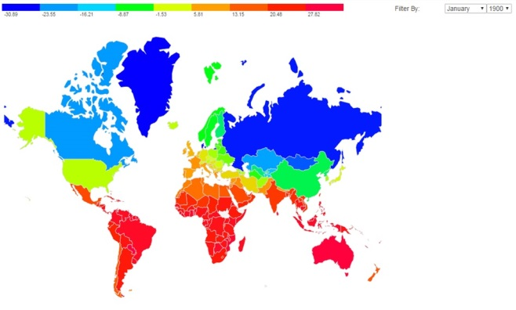Fig 2: A choropleth of the world map indicating the average land temperature across globe between 1900 and 2013

**2.2.2 USA Map with states’ average temperature**

The choropleth map of USA shows the world map color coded in blue (cool) to red (hot) as shown in Fig 2. Hovering on a country shows the USA state’s name and land average temperature. Filtering can be done based on months and years.

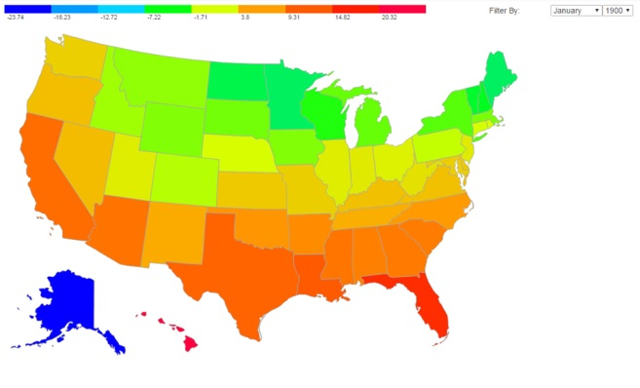Fig 3: A choropleth of the USA map indicating the average land temperature across USA between 1900 and 2013

**2.2.3 Detailed analysis of global temperature by country, year, month**

The bar chart shows land average temperature as shown in Fig 4. Hovering on a bar shows the country’s name/month/year and land average temperature. Filtering can be done based on countries, months and years. Grouping of data can do based on country, month, year.

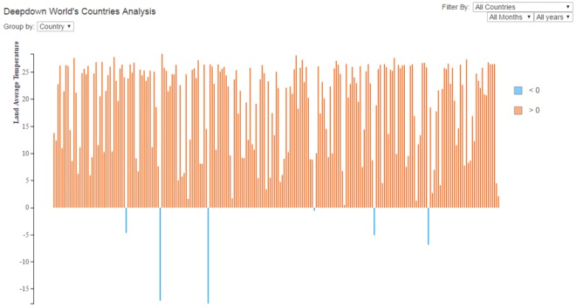Fig 4: A bar chart indicating the deep down analysis of land temperature across countries

**2.2.4 Detailed analysis of USA temperature by state, year, month**

The bar chart shows land average temperature as shown in Fig 5. Hovering on a bar shows the USA state’s name/month/year and land average temperature. Filtering can be done based on states, months and years. Grouping of data can do based on country, month, year.

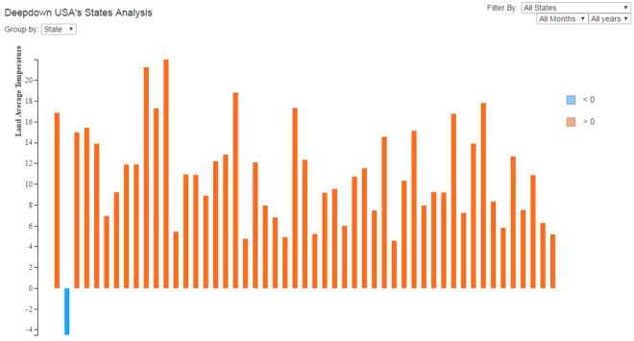Fig 5: A bar chart indicating the deep down analysis of land temperature across states of USA

**2.2.5 Global average, maximum, minimum temperature by month and year**

The area chart (context and focus) shows land maximum, average, and minimum temperature of globe as shown in Fig 6. Hovering on chart shows the date and land maximum, average, minimum temperatures of globe. Top chart is focus and bottom one is context. We can zoom for the certain period of time on context part (bottom) and see the temperatures in detail on focus part (top).

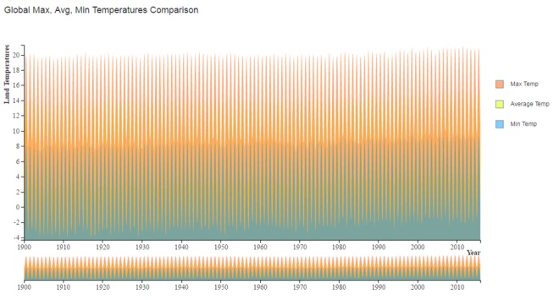Fig 6: A context focus chart indicating the global maximum, average, minimum land temperatures between 1900 and 2013

**2.2.6 Temperature for a country by month and year**

The multiline chart shows land average temperature for each country in all moths with respect to year as shown in Fig 7. Hovering on each line shows the month name, year and land average temperature. We can select each country to analyze the temperature in detail.

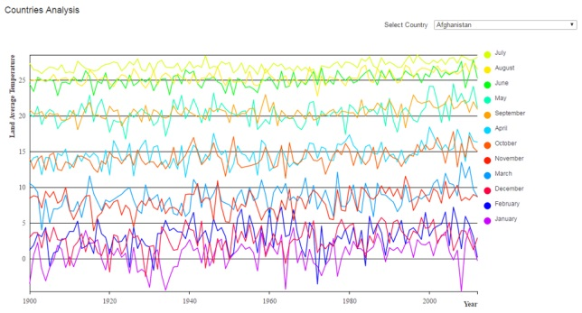Fig 7: A multiline chart with complete analysis for every country between 1900 and 2013

**2.2.7 Uncertainty in temperature measurement with accuracy**

The scatter plot shows accuracy in measuring the temperature from 1750 to 2015 as shown in Fig 8. Hovering on each point shows the year and accuracy value by changing the color to red. Accuracy is calculated as (1/uncertainty in temperature measurement). Radius of each point is value of accuracy. Legend contains accuracy values which are equal to radius of points. On hover to legend of accuracy value shows the corresponding points on plot.

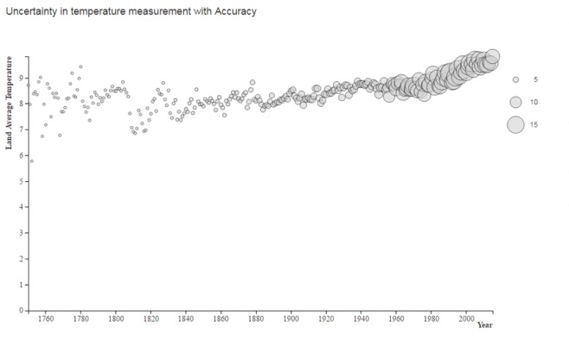Fig 8: A scatter plot for uncertainty in temperature measurement with accuracy from 1750 to 2015

**3 EVALUATIONS**

From the visualizations, we found few insights for global temperature changes. As our merged dataset was limited to data between 1900 and 2013, it is possible to observe changes in temperature and improvement in accuracy of uncertainty calculation. The derived insights from visualizations are as follows:

* From the choropleth, we can observe that places like in southern hemisphere like Africa, Australia are general hotter than countries in the northern hemisphere like Russia, Canada, and Greenland
* From USA choropleth, we can observe a similar trend in which the northern states like Montana, Minnesota, and Alaska are always colder than southern states like Florida, and Hawaii
* From the Uncertainty in temperature measurement with Accuracy chart, we clearly see the increase in accuracy of measurement over the years with improvements in devices and technologies used for temperature measurements

**4 CONCLUSIONS**

In this project, we presented TempRecoder, a visualization tool for analyzing the land average temperature and uncertainty in measurement. By combining multiple visualizations with filterable data, we hope to make an easy to understand way for analyze the temperature. Our hope is that separately visualizing land average temperature; maximum, average, minimum temperature of globe and temperature uncertainty measurement data should help provide a clear picture to the whole situation. The visualizations and their associated actions are easy to use and arranged to provide an intuitive contextual relationship between the data and analysis.

Additionally, using both the United States and world map, we have shown use cases of how the system may be used to analyze past trends. Using this analysis, we can predict the future temperature changes and how to reduce the increase in temperature periodically. Also predict the factors that are influencing in increasing the temperature. These cases utilize every feature of the system with contextual visualizations to provide a clear understanding of the data and allow for insights into their relation.

For future work and an interesting approach, future implementations could involve researching and analyzing more factors like effect of carbon dioxide, global warming on temperature changes.

**REFERENCES**

1. Scott R. Loarie, Philip B. Duffy, Healy Hamilton Gregory P. Asner, Christopher B. Field and David D. Ackerly (2009). The velocity of climate change. *nature, 462,* 1052-1055, doi:10.1038/nature08649.
2. James Hansen, Makiko Sato, Reto Ruedy, Ken Lo, David W. Lea, and Martin Medina-Elizade (2006). Global temperature change. *Proceedings of the National Academy of Sciences of the United States of America, 103(39),* 14288-14293, doi:10.1073/pnas.0606291103
3. Robert Rohde, Richard A. Muller, Robert Jacobsen, Elizabeth Muller, Saul Perlmutter, Arthur Rosenfeld, Jonathan Wurtele, Donald Groom and Charlotte Wickham (2013). A New Estimate of the Average Earth Surface Land Temperature Spanning 1753 to 2011. *Geoinfor Geostat: An Overview 1:1*, doi:10.4172/2327-4581.1000101
4. Mike Bostock, D3.js - Data-Driven Documents; <https://github.com/mbostock/d3/wiki>